Guide to use of specifications in Reference Architectures

**Purpose**: to provide examples of how to work with specification objects in reference architecture, provide classification of specifications, naming and content.

**Audience**: creators of reference architecture

Contents

1 What is a specification? 1

2 Specification Structure 2

2.1 Title and Reference: 2

2.2 Classification: 2

2.3 Identification: 3

2.4 Description: 3

2.5 Document Details: 3

2.6 Related Documents: 3

2.7 Example Specification Entries 3

2.7.1 ITS Directive 3

2.7.2 DATEX II standards 4

3 Where to link the specification 5

3.1 Motivational Layer - ITS Service: 5

3.2 Functional View - Function: 5

3.3 Organizational View - Actors: 6

3.4 Physical View - System/Subsystem/Module: 6

3.5 Communications View - Interface: 6

3.6 Discussion 6

# What is a specification?

A specification is a detailed, precise description of the requirements, design, behaviour, or characteristics of a system, component, or process. Specifications are used to ensure that everyone involved in a project understands what is expected and to provide a basis for verifying that the final product meets the required standards.

There are several types of specifications, each serving different purposes:

1. **Functional**: Describe the specific functions and features that the system or component must perform from the user's perspective. They focus solely on what the system should do, without delving into how it achieves these functions.
2. **Performance**: Outline the required performance metrics, such as speed, capacity, and reliability. They strictly define the measurable criteria that the system must meet, without specifying the functions or design details.
3. **Technical**: Provide detailed technical information, including materials, dimensions, and manufacturing processes. They focus exclusively on the technical aspects and physical characteristics of the system or component.
4. **Design**: Detail the design aspects, including drawings, schematics, and design principles. They concentrate on the visual and structural design elements, without specifying the technical details or performance metrics.
5. **Interface**: Define how different systems or components will interact with each other, including communication protocols and data formats. They focus on the interaction and integration points, without detailing the functions, performance, or design aspects.
6. **Legal**: Include legal documents such as EU delegated acts, which supplement or amend non-essential elements of existing legislation. These specifications ensure that laws remain relevant and effective, providing detailed legal requirements and updates
7. **Recommendation**: Provide guidelines or best practices that are not mandatory but are suggested to achieve optimal performance, compliance, or quality. These can include industry standards, advisory notes, or expert recommendations.

# Specification Structure

This structure ensures that each specification is clearly identified, classified, and described, making it easier to reference and understand its context and use.

## Title and Reference:

* **Title**: Provide a concise, specific name for the specification.
* **Reference**: Include a direct reference to the document or set of documents.
* **Example**:
  + **Title**: ITS Directive 2010/40
  + **Reference**: ITS Directive 2010/40

## Classification:

* **Type**: Clearly classify the specification into one of the defined types (Functional, Performance, Technical, Design, Interface, Legal, Recommendation).
* **Example**: Legal Specification

## Identification:

* **Full Name and Hyperlink**: Provide the full name of the specification and a hyperlink to the text.
* **Example**: Commission Implementing Decision M/453

## Description:

* **Contextual Use**: Describe how the specification is used in the context of the ITS Service. Include a paragraph or more of text.
* **Example**: The ITS Directive 2021/40 specifies the requirements for the deployment of Intelligent Transport Systems (ITS) in road transport and for interfaces with other modes of transport. It aims to ensure interoperability and continuity of ITS services across the EU, enhancing road safety, traffic efficiency, and environmental sustainability.

## Document Details:

* **Document Number:** Include the document number if applicable.
* **Publication Date**: Provide the publication date.
* **Example**:
  + **Document Number**: 2021/40
  + **Publication Date**: June 2021

## Related Documents:

* **List of Related Documents**: Provide references to related documents or standards that are closely connected.
* **Example**:
  + **Related Documents**:
    - Standard 123456-1
    - Standard 123456-2

## Example Specification Entries

### ITS Directive

**Title**: ITS Directive 2010/40/EU  
**Reference**: [ITS Directive 2010/40/EU](https://eur-lex.europa.eu/eli/dir/2010/40/oj/eng)  
**Type**: Legal Specification  
**Full Name and Hyperlink**: [Directive 2010/40/EU of the European Parliament and of the Council of 7 July 2010](https://eur-lex.europa.eu/eli/dir/2010/40/oj/eng)  
**Contextual Use**: The ITS Directive 2010/40/EU establishes a framework for the deployment of Intelligent Transport Systems (ITS) in the field of road transport and for interfaces with other modes of transport. It aims to ensure interoperability and continuity of ITS services across the EU. The directive obligates member states to exchange traffic and travel information data and make them available via National Access Points (NAPs), facilitating the provision of real-time traffic information, multimodal travel information, and other ITS services. This enhances road safety, traffic efficiency, and environmental sustainability across the EU.  
**Document Number**: 2010/40/EU  
**Publication Date**: 7 July 2010  
**Related Documents**:

* **Commission Delegated Regulation (EU) No 885/2013**: Supplementing Directive 2010/40/EU with regard to the provision of information services for safe and secure parking places for trucks and commercial vehicles. [Link](https://eur-lex.europa.eu/legal-content/EN/TXT/?uri=CELEX%3A52021PC0813)
* **Commission Delegated Regulation (EU) No 886/2013**: Supplementing Directive 2010/40/EU with regard to data and procedures for the provision, where possible, of road safety-related minimum universal traffic information free of charge to users. [Link](https://eur-lex.europa.eu/legal-content/EN/TXT/?uri=CELEX%3A52021PC0813)
* **Commission Delegated Regulation (EU) 2015/962**: Supplementing Directive 2010/40/EU with regard to the provision of EU-wide real-time traffic information services. [Link](https://eur-lex.europa.eu/legal-content/EN/TXT/?uri=CELEX%3A52021PC0813)
* **Commission Delegated Regulation (EU) 2017/1926**: Supplementing Directive 2010/40/EU regarding the provision of EU-wide multimodal travel information services. [Link](https://eur-lex.europa.eu/legal-content/EN/TXT/?uri=CELEX%3A52021PC0813)
* **Commission Delegated Regulation (EU) 2019/1745**: Supplementing Directive 2010/40/EU regarding the provision of cooperative intelligent transport systems (C-ITS). [Link](https://eur-lex.europa.eu/legal-content/EN/TXT/?uri=CELEX%3A52021PC0813)
* **Commission Delegated Regulation (EU) 2022/670**: Supplementing Directive 2010/40/EU regarding the provision of information services for safe and secure parking places for trucks and commercial vehicles (repealing Regulation (EU) No 885/2013). [Link](https://eur-lex.europa.eu/legal-content/EN/TXT/?uri=CELEX%3A52021PC0813)

### DATEX II standards

**Title**: DATEX II Standard Series  
**Reference**: [CEN/TS 16157](https://datex2.eu/specifications/)  
**Type**: Technical Specification  
**Full Name and Hyperlink**: [CEN/TS 16157](https://datex2.eu/specifications/)  
**Contextual Use**: The DATEX II standard series provides a comprehensive framework for the exchange of traffic and travel information. It defines the structure and content of messages exchanged between systems, ensuring interoperability and consistency across different platforms. The standards cover various aspects, including location referencing, situation publication, variable message signs, measured data, and more. This ensures that traffic management systems can effectively communicate and share information, enhancing overall traffic efficiency and safety.  
**Document Number**: CEN/TS 16157  
**Publication Date**: Various parts published between 2018-2021  
**Related Documents**:

* [Part 1: Context and Framework](https://datex2.eu/specifications/)
* [Part 2: Location Referencing](https://datex2.eu/specifications/)
* [Part 3: Situation Publication](https://datex2.eu/specifications/)
* [Part 4: Variable Message Sign (VMS) Publications](https://datex2.eu/specifications/)
* [Part 5: Measured and Elaborated Data Publications](https://datex2.eu/specifications/)
* [Part 7: Common Data Elements](https://datex2.eu/specifications/)

# Specification tree and linkage to NRA

## Specification tree and folder structure

* **Storage**: Specifications instances are stored within the supplements/specification package, divided initially (this might change) to several subfolders:
  + Legal = for all legal documents
  + Technical = for all standards
  + Recommendation = for all NAPCORE and other recommendations
  + Profiles = for all data standard profiles
* **Compacting**: especially standards are represented by ONE instance – even if multipart (DATEX, NETEX etc.)
* **Order**: Specification objects are hierarchically linked in this order:
  + directive -> regulations -> implementation act -> standard -> profile
  + recommendations usually does not have hierarchy
* Backwards compatibility: older specifications that are fully replaced by new ones are placed into a “history” subfolder all linkages are removed except one to the replacing object

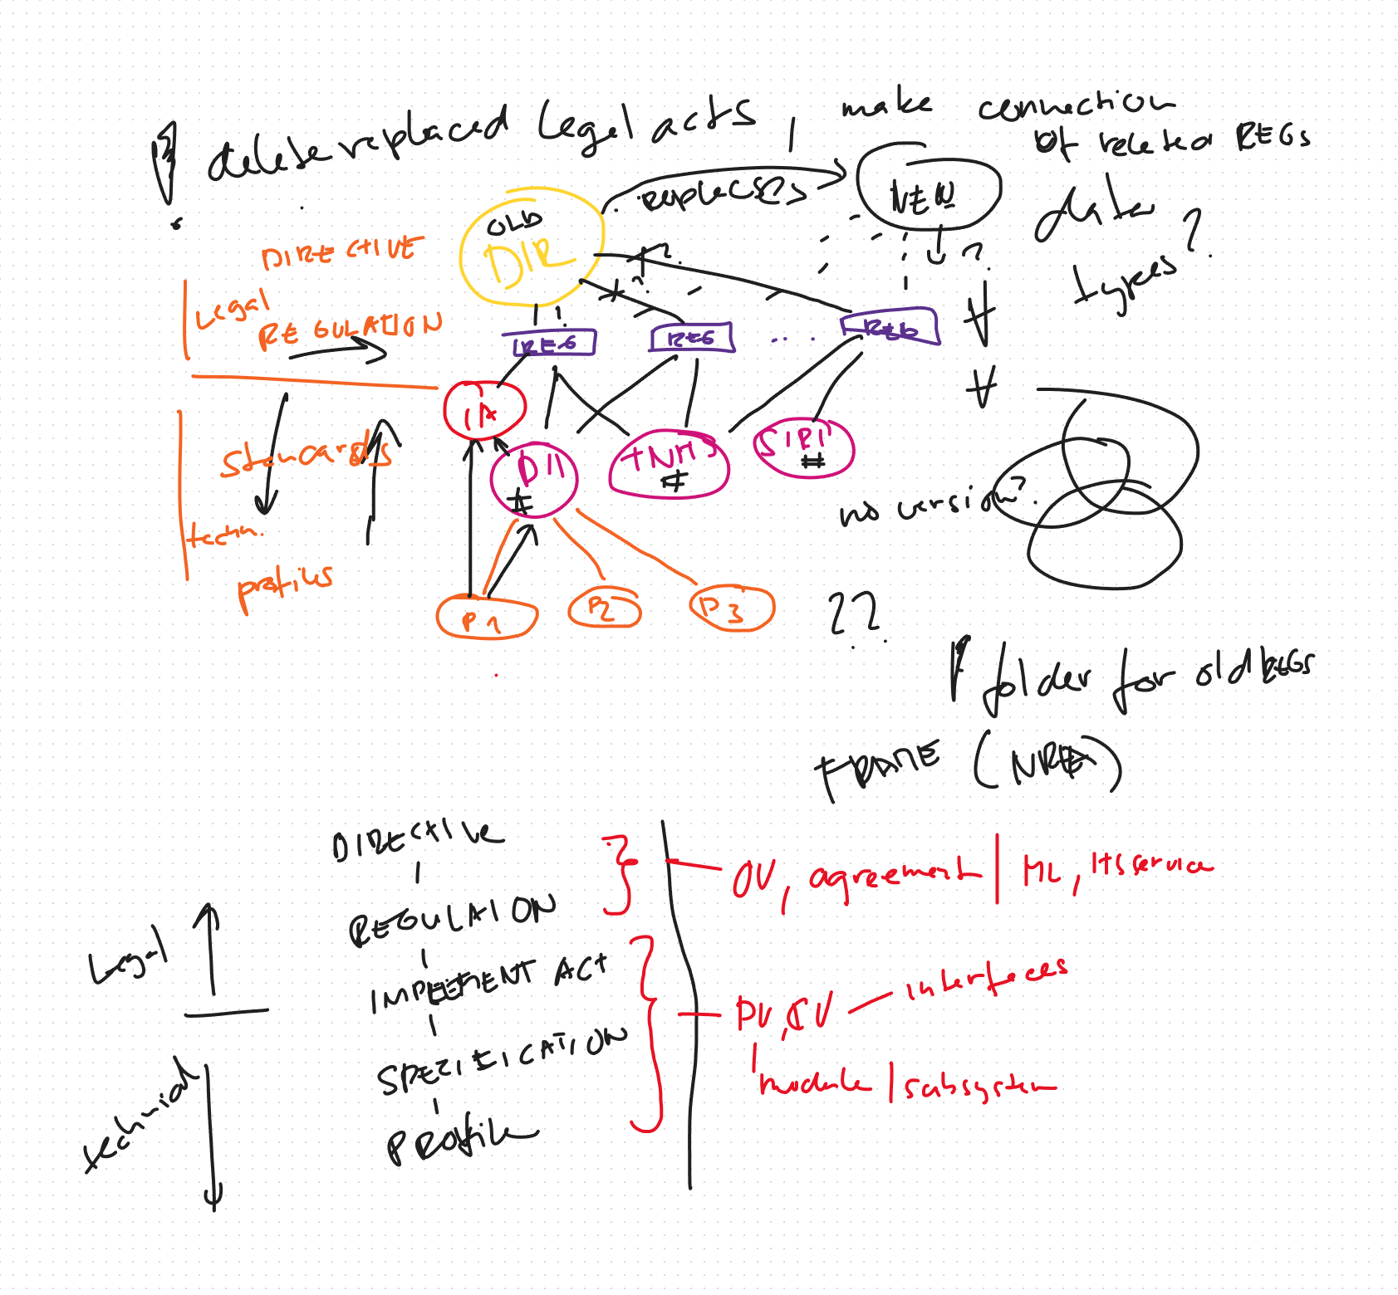

## Mapping of the specifications to NRA

Follow top -> down and generic -> specific approach

### Motivational Layer - ITS Service:

* + **Purpose**: Link specifications that contain general requirements applicable to the entire service.
  + **Applicable Types**: Legal, Functional
  + **Example**:
    - **Specification**: ITS Directive 2010/40/EU
    - **Description**: Establishes a framework for the deployment of ITS in road transport, ensuring interoperability and continuity of services across the EU.

### Functional View - Function:

* + **Purpose**: Link specifications with dominant functional requirements reflected in one or more functions.
  + **Applicable Types**: Functional
  + **Example**:
    - **Specification**: [DATEX II Standard Series](https://datex2.eu/specifications/)
    - **Description**: Defines the structure and content of messages exchanged between systems for traffic and travel information.

### Organizational View - Actors:

* + **Purpose**: Link specifications identifying actors or describing activities and responsibilities. Also link actors to specification that are of their interest but are not directly relevant to NAP (e.g. standards for data description)
  + **Applicable Types**: Legal, Functional, Technical
  + **Example 1**:
    - **Specification**: Commission Delegated Regulation (EU) No 886/2013
    - **Description**: Specifies data and procedures for providing road safety-related minimum universal traffic information free of charge to users.

1. **Example**:
   * **Specification**: [CEN/TS 16157](https://datex2.eu/specifications/)
   * **Description**: Provides a framework for the exchange of traffic and travel information, covering aspects like location referencing and situation publication.

### Organizational View - Agreements:

* + **Purpose**: In Agreements there is already a lot from legal acts – linking to it is natural.
  + **Applicable Types**: Legal
  + **Example 1**:
    - **Specification**: Commission Delegated Regulation (EU) No 886/2013
    - **Description**: Specifies data and procedures for providing road safety-related minimum universal traffic information free of charge to users.

1. **Example**:
   * **Specification**: [CEN/TS 16157](https://datex2.eu/specifications/)
   * **Description**: Provides a framework for the exchange of traffic and travel information, covering aspects like location referencing and situation publication.

## Physical View - System/Subsystem/Module:

* + **Purpose**: Link specifications with tangible technical, performance, or design descriptions that are detailed but not specific to interfaces.
  + **Applicable Types**: Performance, Technical, Design, Interface, Recommendation
  + **Example**:
    - **Specification**: mobilityDCAT-AP
    - **Description**: Provides a framework for the description of traffic and travel information, covering aspects like data types, formats, ownership or licencing.

## Communications View - Interface:

* + **Purpose**: Link specifications with data structure, protocol, or performance descriptions relevant to specific interfaces.
  + **Applicable Types**: Performance, Technical, Design, Interface, Recommendation
  + **Example**:
    - **Specification**: Commission Delegated Regulation (EU) 2015/962
    - **Description**: Specifies the provision of EU-wide real-time traffic information services, including data exchange protocols and performance criteria.

## Where to fit content standards?

Where to fit the DATEX II (CEN/TS 16157) specification within the architecture model:

**Interface View**:

* **Applicability**: DATEX II is inherently designed for defining the structure and content of messages exchanged between systems, making it highly relevant for the interface view.
* **Consideration**: Since DATEX II applies to multiple interfaces, linking it directly to a single interface might not capture its full scope. Also, DATEX II is not a responsibility of the NAP it lies outside it is Content provider responsibility.

**Physical View - System/Subsystem/Module**:

* **Rationale**: Given that DATEX II impacts multiple interfaces, it can be "leveled up" to a subsystem requirement in the physical view. This approach acknowledges its broad applicability across various interfaces within the system. Still missing the point that DATEX is not responsibility of NAP, it does not implement it anywhere.
* **Example**: By linking DATEX II to a subsystem, we ensure that all relevant interfaces within that subsystem adhere to the standard, promoting consistency and interoperability. It is good to mention that data passed over the interfaces should adhere to a certain standard.

**Organizational View - Actor**:

* **Applicability**: DATEX II is inherently designed for defining the structure and content of messages exchanged between systems, BUT systems of Actors, NAP is just an intermediary, not responsible for the handed over content.
* **Consideration**: Since DATEX II applies to Content Provider, linking it directly to him/her might capture the responsibility, but it also lacks the message that the data according to the standard are passed over the systems interfaces.

**Functional View - Function**:

* **Challenge**: Linking DATEX II to a function can be tricky. If the function is too broad, it may not capture the specific requirements of DATEX II. Conversely, if it's too specific, it might miss the overarching ITS service target.
* **Conclusion**: Given these challenges, the functional view might not be the best fit for DATEX II.

**Recommendation**:

* **Primary Fit**: Organizational View – Content Provider Actor. This ensures that the broad responsibility of implementing DATEX II is captured effectively.
* **Secondary Fit**: Physical View - System/Subsystem/Module. This ensures that the broad applicability of DATEX II across multiple interfaces is captured effectively.

By considering these factors, we can ensure that DATEX II is linked in a way that accurately reflects its scope and impact within the architecture model.

## Discussions

### decisions

* 7 categories may be too many. Lest try to fit specifications into **legal** x **technical**
* Let's home all specifications in the supplements\specification folder and only link it to other views
* Do not create super categories of specifications

### process

* Create legal and technical folders in the supplements\specifications
* Move specifications instances from views to supplements while retaining a link
* Fill in the specification objects with the content per this document.
* Link specification as advised in this document, going from top to bottom